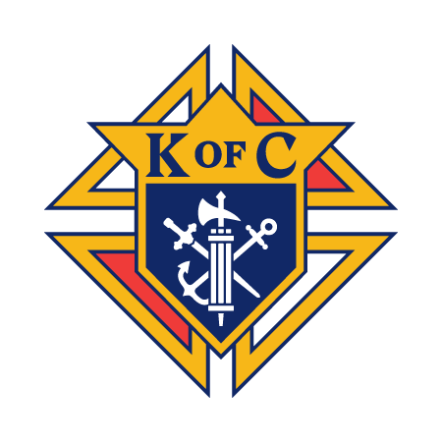
Knights of Columbus Council Meeting Notes September 2025

This meeting transcript outlines a successful month for the Knights of Columbus. The council had a financially successful Old Settlers' Day and burrito sale. There was a presentation from Jim and Kathy Hutchinson about the JPK House of Love foundation, which seeks small, monthly donations to help priests assist people in need in Wyandotte County. The meeting also covered upcoming events, membership updates, and director reports.

Financial Report
- Treasurer Report (Rob Raggeson): At the end of August, the account balance was $54,240.60, an increase of $3,857.40 for the month¹. This was primarily due to receipts from Old Settlers' Day, an equipment purchase (a new freezer), and expenses from Christmas in July². Year-to-date, the council is down $3,839.50³. The new freezer was purchased on sale for $2,700, a significant saving from its original price of $4,800⁴.
- Financial Secretary Report (Jeff Bars): As of September 1, there are 377 members⁵. The council has sent out second notices for dues and is 78% complete with collections⁶.

Director Reports
- Membership Director (David Anderson, Red Sea Santos, and Miles Law): The council has a total of 377 members and officially gained three members for the year⁷. There are four candidates for the upcoming exemplification⁸. The supreme Knight, Patrick Kelly, has a "Go for Two" promotion, where members who recruit two men between September 1 and December 31 are entered into a drawing for a $1,500 gas prize⁹.
- Director of Programs (John Keegan): The First Sunday donuts event was a success, with a profit of $7.75¹⁰. He is looking into whether pre-confirmation youth can receive service hours for helping¹¹. The first Corporate Communion of the school year is this Sunday at the 9 a.m. mass, followed by donuts¹². The St. Mary's Food Kitchen served 325 people with the help of six knights on September 1, and 224 people with the help of three knights on September 13¹³.
- Director of Social Concerns (Bill Sh.): Bill highlighted the Uplift Blue Jean Bash, an event on Friday, November 7, which will feature food and live music¹⁴. The organization, Uplift, serves hot meals, drinks, and emergency supplies to people in camps and where they live¹⁵.
- Worthy Life Director (Troy Mills): Troy discussed the "Cost of Property Experience" and a "retrospective" on the Care Photo event¹⁶. His wife, Phyllis, organizes the Care Photo event, which was successful enough that he can't walk through his garage due to the number of donations¹⁷.

Knight & Family of the Month Designees
- Man of the Month: Bob Davis (July) ¹⁸
- Family of the Month: Tony Martinez's family ¹⁹

Old Business
- The Old Settlers' Day event was more successful than last year²⁰.
- The burrito sale was a success, with a complete sell-out of burritos and tacos²¹.

New Business
- JPK House of Love: Jim and Kathy Hutchinson presented the JPK House of Love foundation, which was started to create a fund to help priests assist people in need without using their own salaries²². They are seeking small, monthly donations ($1, $2, or $5) to help people in Wyandotte County²³.
- Fall Festival: The Fall Festival is this coming Saturday, but more volunteers are needed, especially for cashier and runner positions²⁴.
- Catholic Man: The Catholic Man event is on the 27th of the month²⁵.
- Delta Member Chief Church Drive: The drive is scheduled for October 4, and the council is looking for "ambassadors" to help at all masses²⁶.
- Educational Tickets: Tickets for education will be sold after the meeting and must be returned by November 1²⁷.
- Shalone House: A work day is scheduled for this Thursday, and more volunteers may be needed²⁸.
- Street Cleanup: Oscar is planning a street cleanup for December 6²⁹.

Action Items & Due Dates
- Financial Secretary (Jeff Bars): Continue collecting dues from members who have not yet paid³⁰.
- Membership Director: Encourage members to participate in the "Go for Two" promotion by recruiting new members between September 1 and December 31³¹.
- Membership Ambassadors: Sign up to be ambassadors for the Delta Member Chief Church Drive on October 4³².
- All Members: Sign up to volunteer for the Fall Festival before Friday³³.
- All Members: Sell and return education tickets by November 1³⁴.
- All Members: Help with the Corporate Communion on Sunday at the 9 a.m. mass and with donuts afterward³⁵.
- Oscar: Plan for the Street Cleanup on December 6³⁶.
- Tom F: Gather more volunteers for the Shalone House work day this Thursday³⁷.
- Bill Sh.: Continue to share information about the Uplift Blue Jean Bash on Friday, November 7³⁸.
- Suzanne: Get the notice about the Corporate Communion to the priests³⁹.
- John Keegan: Talk to April to confirm if pre-confirmation youth can receive service hours for helping with the donuts event⁴⁰.
- Grand Knight: Talk to Stephanie for more information about tents for the Fall Festival⁴¹.
- Tom F: Get information about the Uplift dinner and dance time to Richard to post on the website⁴².

