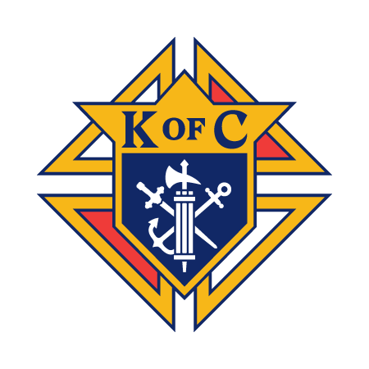
Knights of Columbus Council Meeting Notes November 2025

The November 2025 Council meeting covered key administrative, financial, and charitable initiatives. The Council approved the October minutes and recognized the success of the Veteran's Appreciation Dinner and the Operation Uplift event. Security was addressed with the approval and installation of a digital lock on the Knights' Room door and a new internal key box. While acknowledging an internal conduct issue regarding the misuse of the email list, the Council shifted focus to charitable planning, including discussing the state's urgent call to increase funding for unsponsored seminarians. Awards for the month went to Bill Schoep (Knight of the Month) and the Sew & Sews Quilters (Family of the Month). Finally, the Council approved providing volunteer staff for the church/school staff's December 1st Christmas party bar, confirmed the upcoming Shalom House Dinner on November 20th, and set the date for the Council Christmas Party for January 17th, 2026.

Grand Knight's Report (Alex Montgomery-Soares)
- Review and Acceptance of Minutes: The minutes from the October Council meeting were reviewed and accepted by the members.
- Successful Veteran's Appreciation Dinner (November 8th): The Council hosted a very successful Veteran's Appreciation Dinner on November 8th. This event was well-received, and a special thank you was extended to Troy Williams, Tom Keegan, John Williams, and Brother Knight Denis Meehan for their incredible service and coordination.
- Operation Uplift - Blue Jeans Bash (November 7th): The Council was officially represented at the Operation Uplift Blue Jeans Bash on November 7th. Attending on behalf of the Council were Bill Schoep, his daughter, Alfredo Diaz, and Alex Montgomery-Soares.
- Unsolicited Emails Concern: A major concern was raised regarding Don Hartley sending unsolicited emails to Council members using an acquired list, which is an inappropriate use of membership information and could lead to disciplinary action. The issue has been reported to the state level.
- Knights of Columbus Bowling Tournament: St. Paul's will host the State Knights of Columbus Bowling Tournament across several weekends in February (21st, 22nd, 28th) and March (1st, 7th, 8th). The Council was encouraged to put together one or two teams of five members. St. Paul's Council is covering the team entry fee, and the entry fee for singles and doubles is $50.

Financial Reports

Treasurer's Report (Rob Ragusin)
- Current Financial Report: A comprehensive report on the Council's current financial status was presented by the Treasurer. (To be attached to this meeting notes)

Financial Secretary's Report (Jeff Bartz)
- Membership Card Report: The Financial Secretary provided an update on the status of membership cards.
- Budget Report: A detailed report on the current status of the Council's budget was presented.

Director Reports

Membership Director (Alfredo Diaz)
- Next Exemplification Date: The next degree ceremony for new candidates has been rescheduled and will take place in January 2026.

Faith Directors (Tom Keegan & Oscar Horn)
- St. Mary's Food Kitchen & First Friday Adoration: The Directors gave an update on the ongoing volunteer service at St. Mary's Food Kitchen and the Council's participation in the First Friday adoration.
- Street Cleanup: The next community street cleanup event has been scheduled for December 6th. Volunteer sign-ups will follow.

Community Director (Bill Schoep)
- Next Homeless Uplift: The last Homeless Uplift outing took place on October 11th. Discussions were held to determine the date for the next event.
- Tootsie Roll Drive 2025 Retrospective: The Community Director provided a summary of the 2025 Tootsie Roll Drive. The final tally of funds collected from the drive will be completed after the meeting.
- Shalom House Dinner Retrospective/Updates: The last dinner at Shalom House was held on September 17th. A retrospective of that event was given, along with updates and plans for the next dinner.

Life Director (Troy Mills)
- 2025 Sausage Sale Delivery: The Life Director confirmed that all ordered items from the 2025 Sausage Sale have been successfully delivered to the members who placed orders.

Awards and Recognition
- Knight of the Month (November 2025): The honor was awarded to Bill Schoep.
- Family of the Month (November 2025): The honor was awarded to the Sew & Sews Quilters of Prince of Peace.
- Knight and Family of the Year Vote: Ballots were distributed, voted upon, and counted to determine the Knight and Family of the Year for the entire 2025 fraternal year.
  - Knight of the Year (Overall 2025): Oscar Horn.
  - Family of the Year (Overall 2025): Andy Boehm Family

Old Business
- Financial Benefit Night (FBN) - FREE Financial Webinar: Two financial webinars were offered on November 5th and November 12th. The Council hosted a viewing party with pizza for the November 12th session.
- Exemplification & New Knights: The Council welcomed four new knights during the reporting period. The Grand Knight met with each new member individually. This adds up to a 40% recruitment success year-to-date.
- Veterans Appreciation Dinner (November 8th): (See Grand Knight's Report above for details.)
- Operation Uplift - Blue Jeans Bash (November 7th): (See Grand Knight's Report above for details.)

New Business
- Next Shalom House Dinner: The date for the next meal service at Shalom House is scheduled for November 20th.
- FIRE Retreat 2026: Discussions began regarding the plans and preparation dates for the 2026 FIRE Retreat, including organizing burritos for breakfast.
- Knights’ Room Security Upgrade: Following the discussion in the previous meeting, a digital lock doorknob has been successfully installed on the Knights’ Room door. This upgrade allows the code to be changed easily and resolves the ongoing issue of lost keys.
- Key Box Installation: A further security measure was approved for the installation of a key box inside the Knights’ Room to store and organize various keysets, which will be named and tagged for easy identification and secure management.
- Council 7909 Christmas Party: The date for the Council's Christmas Party has been set for January 17th. The Parish Hall will be reserved for the event, with a budgeted amount of $2,000. The suggested cost for attendees is $15 for a single ticket or $25 for a couple.
- Seminarian Funding Discussion: The state is encouraging all councils to increase funding for seminarians with little or no financial support, aiming for at least $1,000 per seminarian. A list of approximately 13 seminarians, including six with zero support, will be reviewed at the next officers' meeting to determine if the Council can provide assistance.
- Church/School Staff Christmas Event (December 1st): The Council approved a motion to man/staff the bar for a staff Christmas get-together/retreat for about 80 church and school staff on December 1st. It was decided the Council would not supply the alcohol (including the requested margaritas/mixes) but would serve them if the staff provides the beverages.

